Pollinator Gardens
07.10.2021
Revised 07.15.2021
─
Anatta A. Watts
304-1555 Graveley Street
Vancouver BC V5L 3A5

Overview
Thank you for looking over my proposal for Pollinator Gardens at the Community of Christ Church, Vancouver Congregation. The goals of this document are:
- To open conversation with our community about Pollinator Gardens
- To present the basic idea of pollinator gardens at our 3333 Kaslo Street location as an opportunity
- To present one possible plan for building pollinator gardens at this location
- To request approval-in-principal for the First Growth and proceed to a detailed costing of the First Growth (see below for definition)
According to the City of Vancouver, the diversity of pollinators, mostly bees and butterflies, have been suffering through the escalating loss of habitat and use of petrochemicals in agriculture and urban garden and lawn space. Pollinator gardens are identified as an important way to reclaim urban land space for pollinators and achieve a meaningful impact on their ability to survive and thrive. (https://vancouver.ca/home-property-development/support-bees-and-butterflies.aspx).

Intentions
- To have a meaningful, positive impact on the many different pollinators in our area by growing thriving pollinator gardens.
- To establish, care for, and communicate with others about our pollinator gardens as practice of discipleship.
- To nurture our congregation through the shared experiences of cultivating and enjoying our pollinator gardens.

Acknowledgments
Our congregation has many skilled gardeners who have served our Church grounds over the years. All of our Vancouver congregation would naturally have a relationship with the physician space and a personal sense of investment in what how we decide to steward our space. I want to acknowledge that, as a new member of our Community of Christ family, I have little knowledge of those relationships and histories of service, and I do NOT want to fail to honor them. This proposal is to be considered within that larger context, a context that only the whole congregation will be able to bring to discussion of the idea of Pollinator Gardens.

Additional Funding
There are grants available for community projects, which Pollinator Gardens at our Church could qualify for, and for planting gardens for pollinators or native plant species. I have registered to be notified when applications are open for a $500 Community Grant, and would pursue other funding options to support any Pollinators Garden approved by our Church.
Further, some companies selling soil and pollinator and native plants offer community partnerships wherein we could access reduced pricing.

One Step at a Time …
Please consider the different Growths described on their own, as well as potentially part of a more comprehensive opportunity. Our community may choose to do any portion of what is outlined here. The time now is for creative discussion!

Spaces for Pollinator Gardens
Our 3333 Kaslo Street location offers an astounding opportunity to grow magnificent pollinator gardens. Every angle has excellent sun exposure and there are multiple large sections of ground space. Each of these spaces also invites various kinds of interaction for people with the pollinator gardens that could be grown there.
Because of the multitude and diversity of spaces, I am suggesting that we would take a sequential approach to creating our pollinator gardens. Going forward with the first two Growths in 20201, then with the option of the second two Growths in 2022, we can ensure responsible use of any budget that may be dedicated to this project. As well, this approach presents a reasonable work plan for those doing the physical labor of preparing the ground and planting. Finally, a sequential approach would facilitate us applying what we learn from earlier work on our pollinator garden to later work, or for our community to pause or end the process of cultivating new pollinator garden spaces.
I have included a color-coded drawing below for visual reference. The different spaces are:

First Growth (2021)
- Strip between parking lot and neighboring property to the south (pictured below)
- Strip between parking lot and south side of building
- Strip between north side of building and alley, including the nooks in north-west corner of building
Second Growth (2021)
- Outdoor atrium in centre of church (begins here, carries into Third Growth)
Third Growth (2022)
D) Outdoor atrium in centre of church (continued from Second Growth)
- North-east corner, where we have a bench and a Reading Library
- West-facing lawn at rear of building, between sidewalk along building and the alley
- South-east corner underneath the large tree beside our main access driveway
Fourth Growth (2022)
- On the east (front) side of building, the narrow strip between the sidewalk along the side of the building to the front door, and the section on the south side (left side as you enter the building) of the front walkway

Basic Principles
I have charted detailed plant selections for each of the areas. Only some of the plants are mentioned in this document, and they are definitely subject to change as more of our congregation become involved and as we learn more. Following are the principles that I have tried to apply in planning:
- Diversity
As we witness in all of Creation, diversity is a basic characteristic of life. The greater diversity we have in what we plant, the healthier the gardens themselves will be, the greater diversity of pollinators we will serve, and the greater the length of time each year our gardens will be blooming.
- Soil health
The healthier the soil, the more resilient the plants and the gardens as a whole will be, and the more beneficial the substances from the gardens will be for the pollinators and birds.
- Native plants
The plants the co-existed and co-evolved in this part of the world will naturally contribute more synergistically to the soil and the other animals and plants that they have co-evolved with. Further, planting native species contributes to those species surviving into the future.
- Invitation and engagement
Preparing, planting, caring for, and enjoying our Pollinator Gardens will offer diverse and meaningful opportunity to come together as a congregation. But the Pollinator Gardens would offer even more. By designing our already highly visible spaces in a way that is inviting to others, we crete an excellent setting for engaging people with our message about the sacredness of Creation and how Community of Christ Church is striving to work with others to care for it.

DIAGRAM OF POTENTIAL GARDEN PLOTS
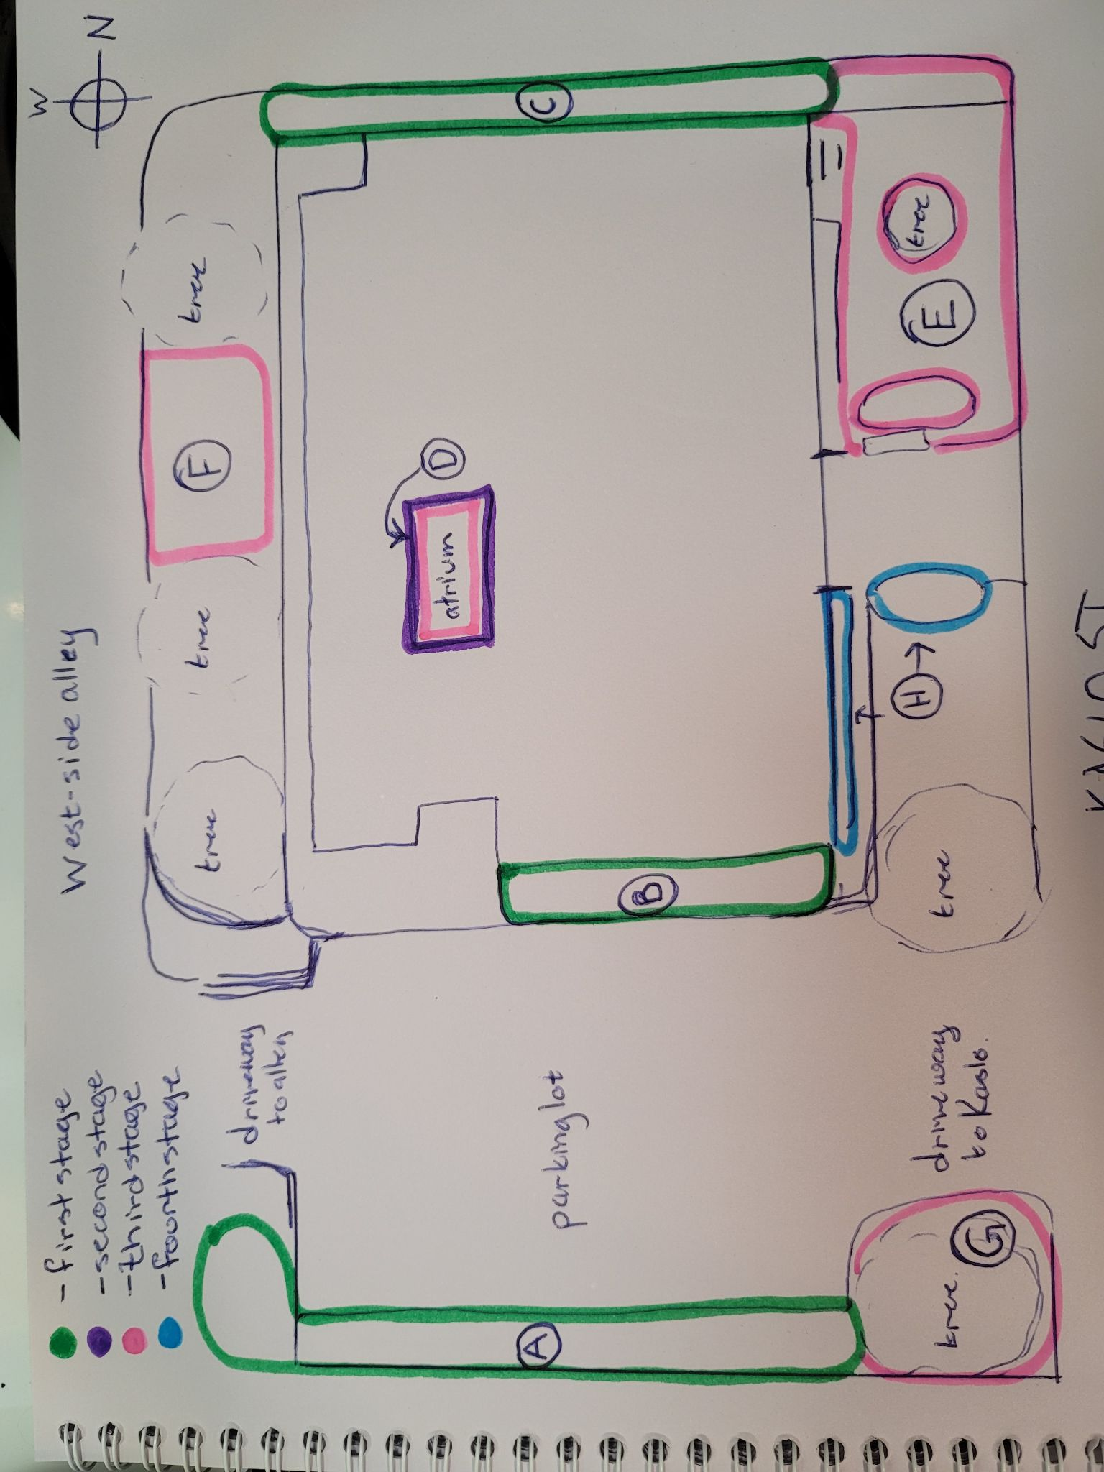

2021
To complete the first two growths, we would need to purchase:
- Truck load of organic soil
- Plants
- 6 frames for climbing plants
We would need to source (borrow or ask community to share):
- Shovels
- spades

First Growth (green)
- Strip between parking lot and neighboring property to the south (pictured below).
- Strip between parking lot and south side of building.
- Strip between north side of building and alley, including the nooks in north-west corner of building.
Preparing the ground: For (A) and (B), there will be removal of existing plants, then digging up the soil, then adding new soil. For (C), there will be outlining the garden in the existing lawn, then digging up the lawn in the outlined space, digging up the soil, and adding new soil.
For (A), the removed plants will be either turned into the new garden soil or removed for composting. For (B), the ornamental flowers already there will be offered to people to take home; ‘weeds’ will be composted. For (C), the turf will be removed for compost.
I suggest we do all the ground prep for these three spaces in tandem. This will allow us to have a Planting Party (see below) for all three spaces.
Planting: The primary plants for (A) include varieties of raspberry, salmonberry, thimble berry, white clover, and camomile, plus serviceberries at the south-west corner.
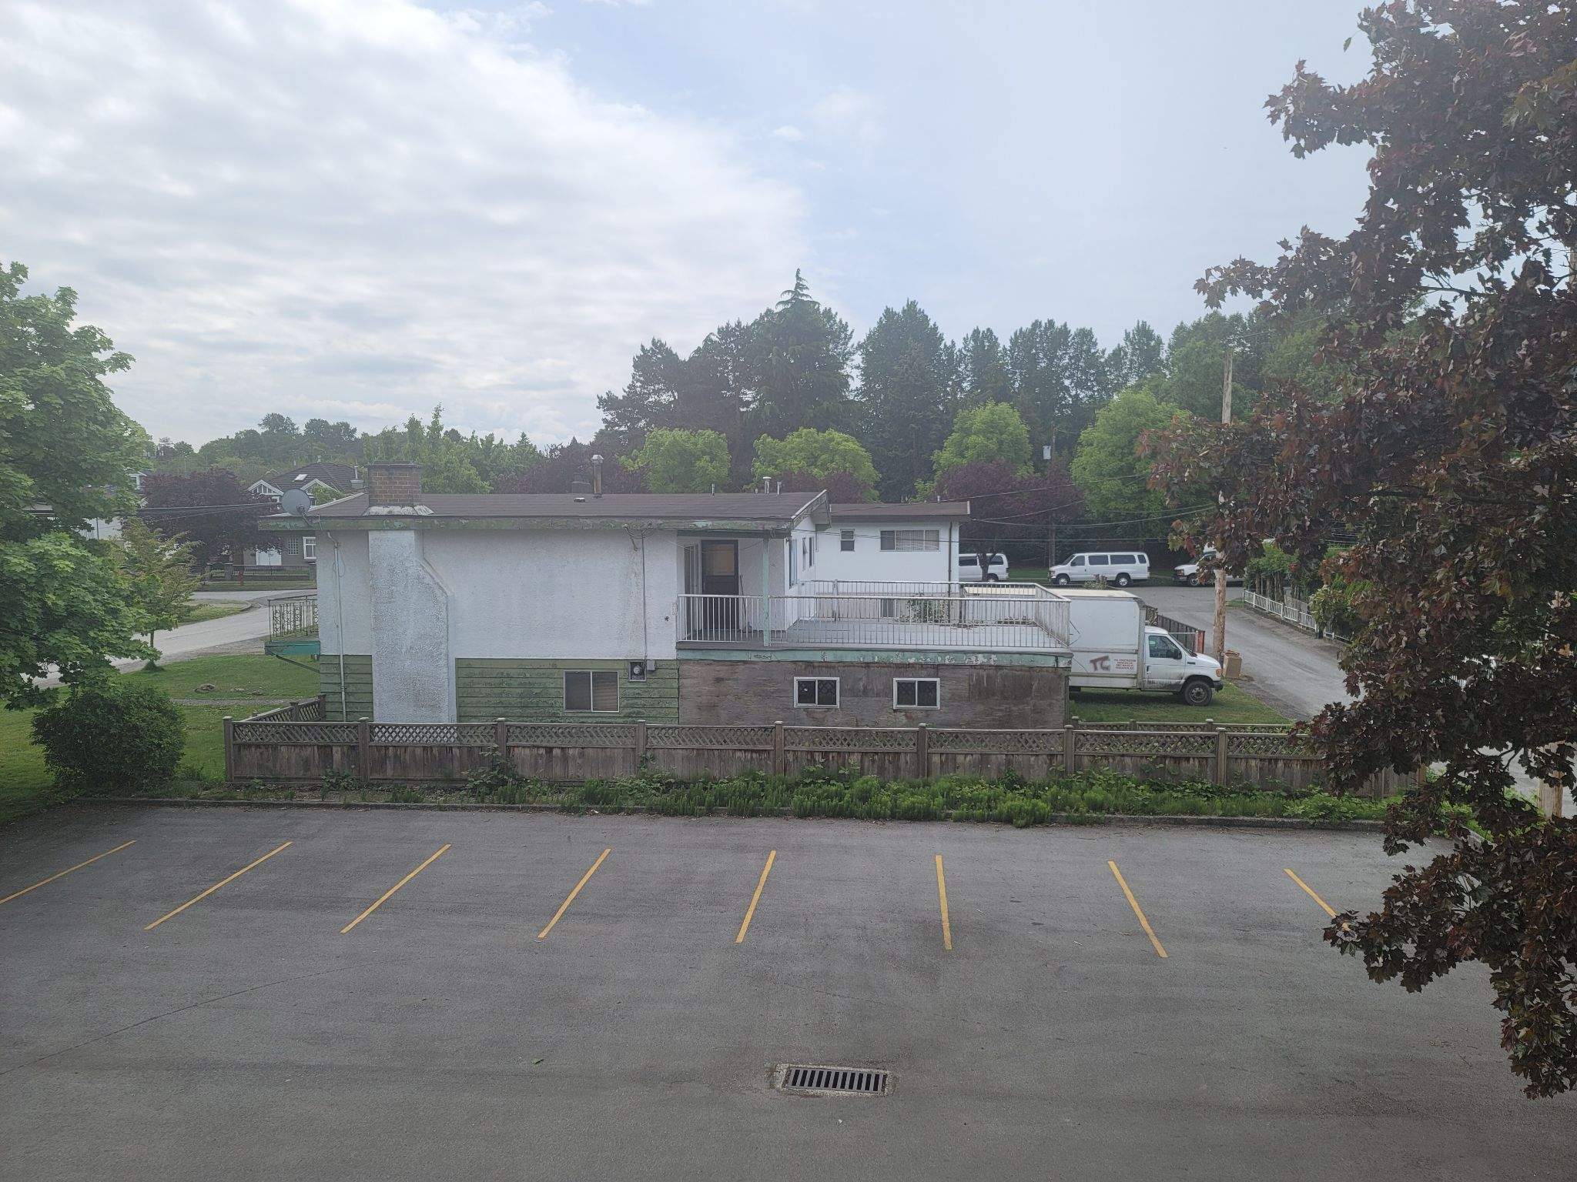

(Imagine abundant, diverse flowering berry bushes with white clover and camomile.)

Primary plants for (B), the south-facing wall of the church, include rosemary, lavender, thyme, sage, oregano, and honeysuckle. The honeysuckle will need some frames to grow up on.
FInally, along the north side of the building, parallel to the alley, the primary plants for (C) include honeysuckle, heather, purple toadflax, yellow mustard, borage, lily of the valley, and geranium.
Proposed timeframe: Have all the ground prep complete by July 31, 2021; hold our Planting Party on Sunday, August 8th, 2021.

Second Growth (purple, then pink)
D. Outdoor atrium in centre of church
Basic weeding and tidying: As you can see in the picture below, this could be a good place to start.
Proposed timeframe: Prior to first in-person service.
Collaborative planning for space: One of the features of this space is that it is visible from within The Sanctuary. It contributes to the energy and experience of congregating and communal prayer. Planning a renewal of this space with that in mind adds to the dimensionality of both The Sanctuary as well as the actual outdoor atrium.
Also, as a meditative and replenishing space, the air in the atrium carries the clean, moist, mossy fragrances of some forests. The potential for cultivating a truly amazing grotto is awesome.
Proposed timeframe: The collaborative planning could be done by July 31, 2021.
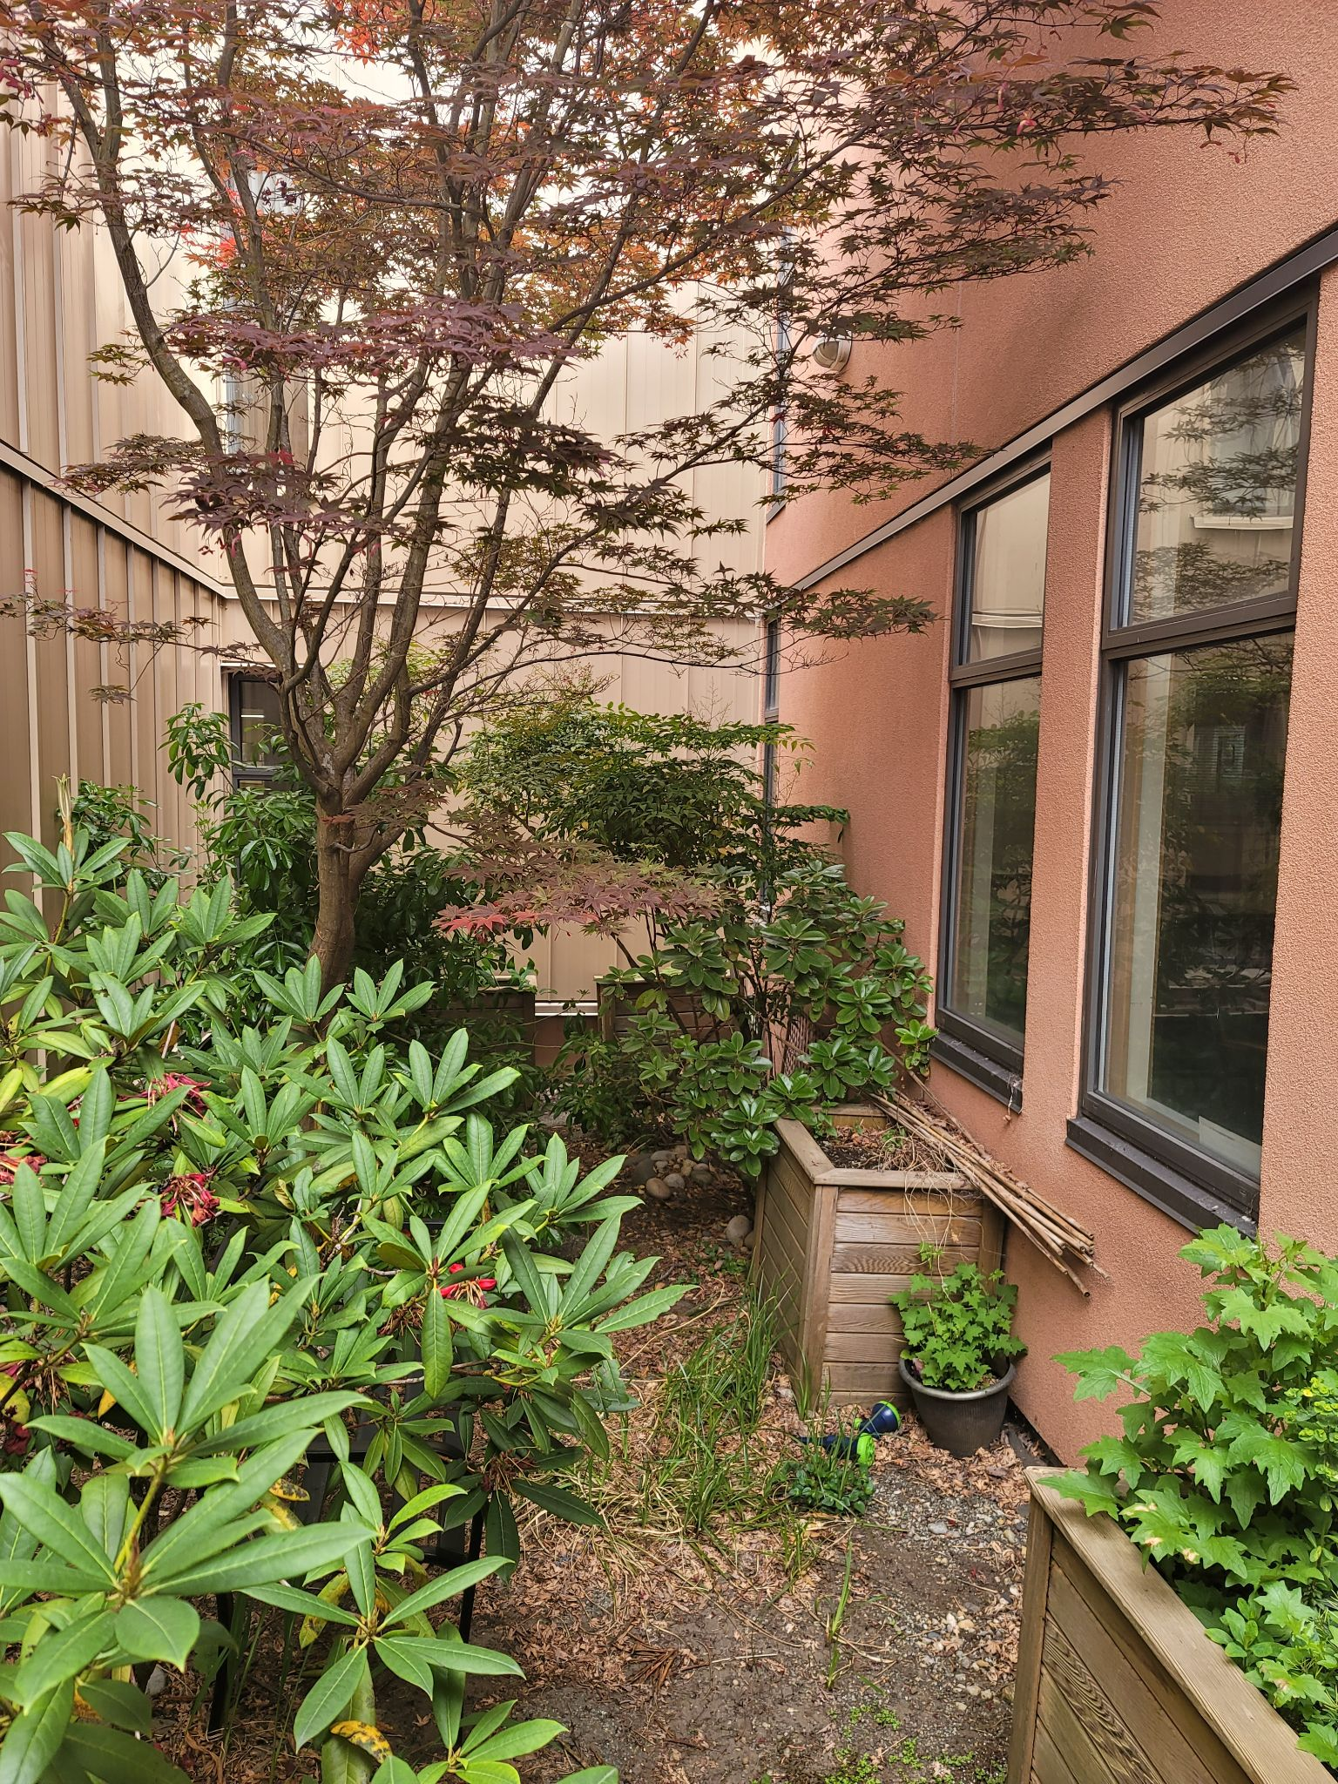

2022
For Growths 3 and 4, we would need to purchase:
- Truck load of organic soil
- Plants
- Wood for framed beds and for the grape frame
- Hardware (spikes, screws, nails) for the framing
- Landscaping services to remove the large shrubs
We would have to source:
- Shovels
- spades

Third Growth (pink)
E. North-east corner, where we have a bench and a Reading Library.
Vision: This space is already being offered as a way to engage with our neighbors. The vision in the Pollinator Gardens for this is to expand on that. I have charted out proposed garden spaces, a wandering circular pathway that invites people to slow down and rest, and developed the existing bench invitation. That chart is not included in this document.
D. (back to atrium)
F. West-facing lawn at rear of building, between sidewalk along building and the alley.
G. South-west corner, the space beneath the large tree
Preparing the ground: For (D) and (E), removing some shrub-sized plants. For (E), the north-east corner space, and (F), the rear lawn, outlining the gardens, cutting the turf, and digging up the turf and underlying soil, and adding new soil to build up beds. For (D), turning over some garden spaces and adding new soil. (G) is a space we could plant a small vegetable garden in one or two raised beds. The raised beds would ensure we don’t interfere with the tree’s root system, and could also create an interesting height to place a bench or some chairs beside for restful moments.
Proposed timeframe: Complete preparing the ground by March 31, 2022.
Planting: In (D), our atrium, we may choose to plant some climbing vines, some ferns, and a moss garden. To be decided. For (E) on the north-east corner, the primary plants include California lilacs, forget me nots, aster, bachelor buttons, rosemary, calendula, and lavendar. For (F), I am suggesting that we install a long arch and plant wild grapes to train up. (G) could be a small vegetable plot in raised bed(s).
Proposed timeframe: Hold our Planting Party in April, 2022.

Fourth Growth (blue)
H. On the east (front) side of building, the narrow strip between the sidewalk along the side of the building to the front door, and the section on the south side (left side as you enter the building) of the front walkway.
Preparing the ground: There are hardy little shrubs planted in the narrow strip along the side of the building, and a big evergreen and a rhododendron along the south side of the front walkway. I propose that these would all be removed. The ground would then be sug up some more, and have new soil added.
Proposed timeframe: Complete the plant removal and prepping of soil by May 31, 2022.
Planting Party: Hold Planting Party in early or mid-June, 2022. Primary plants for these areas would be California lilacs for the south side of the front walkway and a diversity of flowering plants and shrubs in both areas.

Planting Parties - Planting plants, growing relationships!
This will be a highlight of our Pollinator Gardens! Our entire congregation as well as neighbors and other community members can come to together to plant. At a Planting Party, we can offer snacks and refreshment, perhaps music, and certainly plenty of time to chat with others and plant plants for the pollinators.
With the basic planting strategy drawn out, communicated, and all the plants and tools organized and ready, many people within and outside of our congregation can gather and plant. Planting can be personalized so that people can come back over the months to witness how the plant(s) they put into the earth are growing. We can take lots of photos.
Planting Parties will be occasions we plan for, creating lists of people and organizations to invite, sending out invitations, and preparing to be great hosts. Planting Parties will be an important opportunity to exercise any Community of Christ Church social media platforms and to invite the news media to help us share about who we are, what we are doing with our new Pollinator Gardens, and why.

Closing
Thank you for considering my proposal that we build Pollinator Gardens at Community of Christ. There are other opportunities we could look at down the road relating to these Pollinator Gardens, and the entire subject is a wonderful opportunity for congregation’s engagement and participation from the beginning.
For now, please consider approving Growths 1 and 2, the installation of Pollinator Gardens in the three east-west strips and the basic tidying, organizing, and planning for our atrium. If you approve this, please advise me of a budget, if any, the Church would like to commit to supporting these first two Growths.
Thank you very much!

Pollinator Garden Resolution

Whereas we, the Community of Christ, recognize the worth of all Creation and are called to action to sustain life on our precious planet, and since the proposal to install Pollinator Gardens at 3333 Kaslo Street has been broadly distributed and discussed with significant support and enthusiasm among members of the congregation, and since “more than 40 percent of insect pollinators globally are significantly threatened [and] … almost 90 percent of wild plants are dependent on insect pollination” (K. Kopec & L.A. Burd, Center for Biological Diversity, Feb 2017), there are congregants who have pledged their willingness to physically maintain the Pollinator Gardens, and that this is one way we as a congregation we may contribute to a life sustaining force in our neighbourhood and community,

Move that the Congregation accept the Pollinator Garden report prepared by A. Watts and proceed with Step 1. First Growth with a budget of $2382.60 for the remainder of the budget year 2021.This budget may be taken from the existing reserves of our congregation, and

Move that the Congregation authorize A. Watts to submit a request for grant funding on our behalf for this garden.

Citation:
https://www.biologicaldiversity.org/campaigns/native_pollinators/pdfs/Pollinators_in_Peril.pdf

Pollinator Garden, First Growth: Budget, Timeline, Personnel & Planting Party

Budget - Total (excluding donations) $Cdn 2,166 + 10% for overruns

Materials:
Organic Soil Ammender $695.11 plus tax for 16.2 cubic yards
Tools (borrow or rent): Total $650
Breakdown -
- 1 tiller, rental $150 at Lowe’s
- 3 wheelbarrows, rental $50 per barrow rental = $150, Rona’s
- Soaker hose and controls, purchase $200 at Lowe’s
50’ of soaker hose at Lowes is $21 plus taxes so say $30
Assuming none at church:
- South end of the parking lot is 75’
- North end of the parking lot is 35’
- Walkway from parking to main entrance of church (east side) is 50’
- North side of church from east corner to stairway is 50’

250’ of soaker hose is $150

Controls for hose new are $60

Plants $766
- California Lilacs $300
  - 3 3G potted $60 X 3 = $180
  - 4 2G potted $30 X 4 = $120
- Honeysuckle $90
  - 3 1G potted $30 X 3 = $90
- Lavendar $220
  - 2G potted, $30 X 3 = $90
  - 1P potted, $13 X 10 = $130
- Rosemary $78
  - Potted, $13 X 6 = $78
- Raspberries $78
  - 1G potted $13 X 6 = $78
DONATIONS
- Etc.

Timeline
August 22, 2021 Approval of Motion at Business Meeting

August 22, 2021 Strike a Planting Party Planning Committee
Arrange work Party for upcoming week
Rent tiller (advance rental)
Rent barrows (advance rental)
Order soil

August 23-25, 2021 Delivery of soil to 3333 Kaslo Street
Rent tiller; bring tiller and pointed shovels to 3333 Kaslo St
1st Work Party to prepare plots (in afternoon, pending approval of motion prior)
Planting Party: Invitations sent out

August 23-27, 2021 Optional time to do work on plots
Planting Party Planning in progress

August 28, 2021 Final Work Party to prepare plots

September 5, 2021 Planting Party, Community of Christ Church; register our Pollinator Garden with the City of Vancouver

Personnel
Personnel refers to people who have offered their time and labor to prepare the three plots identified in First Growth. The work includes cutting turf and digging up ground, gently removing some existing ornamental flowers for replanting in private residences, and placing new soil in the three plots. Planting will happen during a Planting Party, which will be organized separately.

{list of names}

Planting Party
Our Planting Party will be our first opportunity to communicate and celebrate our excitement about nurturing our community and planet through our Pollinator Garden. A Planting Party team will plan for refreshments, music, ambassadors, photography, setting up the plants and planting tools for the day, sending out invitations to our church and general community, and arranging for media coverage.

